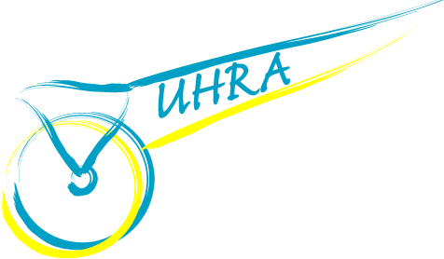 | UNITED HARNESS RACING ASSOCIATION  P O Box 507  CHESTER HILL NSW 2162  Australia  Tel: 0421 055 847  Email: admin@uhransw.com.au

United Harness Racing Association
MEMBERSHIP RENEWAL / APPLICATION FORM
Name:
Address:
 |  | State: | Postcode:
Occupation:
Telephone: | (Home):
 | (Mobile):
Email:
INDUSTRY INVOLVEMENT (please circle)
Owner Trainer Driver Breeder Stablehand Supporter Other
I hereby apply to become a Member of the United Harness Racing Association (UHRA)
In the event of my admission as a Member, I agree to be bound by the Constitution of the Association for the time being in force.

Signature |  | Date

ANNUAL MEMBERSHIP FEE $10.00
Please return this Form with Membership payment.

Money Order/Cheque: | Please make out to “United Harness Racing Association”
 | Post to: UHRA, P O Box 507, CHESTER HILL NSW 2162
Online Payment/  Direct Deposit: | Fill out the Online Membership Form on our website, then transfer $10.00 via Direct Deposit to the following Account Number:
 | BSB: 062 622 Account Number: 1014 9794
 | (For reference, please use your first initial & surname plus UHRA in the description)

